Generic Tree Protection Management Plan for Events

Preserving trees is essential for our district's character and environment. Trees thrive in a harmonious balance with their surroundings. Altering this balance can compromise their health and potential. Since repairing stressed trees is challenging, preventing damage is paramount

This document guides tree protection requirements for any event that may occur near QLDC-owned or managed trees, ensuring their long-term protection, integrity, and overall health.

All events that may occur near public trees must abide by the protection requirements outlined below in accordance with Council’s Tree Policy 2024.

Tree Protection Requirements

While most low-impact events are unlikely to harm trees, should such an event extend into Tree Protection Zones (TPZ), basic tree protection measures must be implemented to prevent damage to public trees. This requires event organisers to have a basic understanding of tree protection requirements to minimise the potential harm to trees.

The event permit holder is responsible for ensuring these measures are implemented and must undertake all reasonable steps to minimise any potential impact on public trees to ensure trees are protected throughout the event.

Tree Protection Zones

The Tree Protection Zone (TPZ) is the area around the tree that is needed for its long-term continued health and growth.

The TPZ radius is determined by the tree's diameter at breast height (DBH) multiplied by 12. DBH is measured at 1.4m from ground level, and TPZ distance is measured as a radius from the centre of the trunk (see Figure 1). If the tree's canopy exceeds this radius, the TPZ should be expanded to encompass the entire above-ground structure of the tree.

In some cases, a TPZ can be modified or reduced due to site factors such as hard surfaces or surrounding infrastructure.
It is critical to safeguard every part of the tree, including roots, trunk, branches, canopy and surrounding soil from damage or disturbance.

Formal Tree Protection Management Plans

For those events with greater impact on trees, QLDC may request a formal Tree Protection Management Plan (TPMP) be prepared by a suitably qualified Arborist. Such plans are essential to tackle challenges concerning highly valued and significant trees, along with addressing soil compaction and implementing ground protection strategies.

The TPMP will typically be required 8-12 weeks prior to your event and must be endorsed by Council’s Arborist and Parks Team.

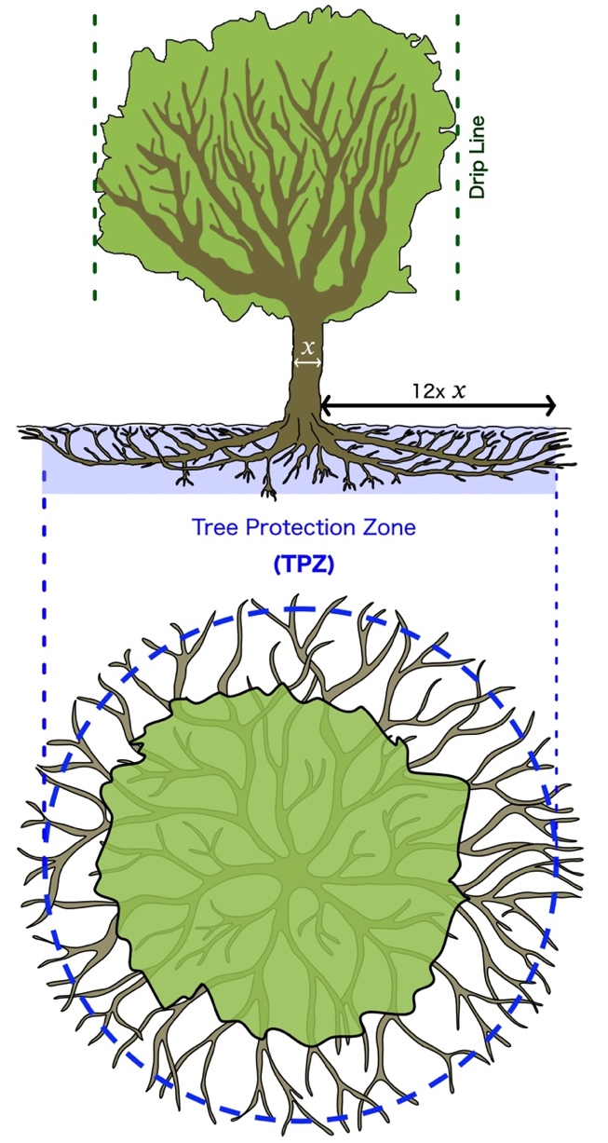
Figure 1: Calculating a TPZ. The TPZ radius is equivalent to the trunk diameter at 1.4m multiplied by 12

Prohibited Actions within a TPZ (Unless Consulted with QLDC or Works Arborist):

- Stockpiling or Storage of materials and equipment | - Lighting fires
- Vehicle traffic (unless on existing paved or hard surface) | - Equipment refuelling
- No discarding of oils or other food preparation liquids | - No staking, digging or disturbance to the soil
- No petrol or diesel-driven stationary machinery (e.g., generators) | - Washing or cleaning equipment
- Preparation of chemicals or materials | - Attaching items and signs to trees
- Disposal of waste materials (including run-off) | - Parking of vehicles and machinery
- No emitting of hot exhaust gasses into the canopy | - Use of herbicides and pesticides
- Activities leading to excessive soil compaction
No pruning or damage to tree branches, trunk or canopy.

Event Infrastructure
All event infrastructure, such as marquees, stages, generators, and portable toilets, must be set up outside the TPZ. In cases where placement outside the TPZ is not possible, protective measures as detailed in this document, must be adhered to, and additional guidance must be sought from a QLDC Arborist.
Ensure that equipment emitting exhaust gases, such as vendor vehicles, maintains at least a three-meter distance from any tree canopy to avoid heat damage.
Avoid placing petrol or diesel-powered machinery, including generators, beneath tree canopies to eliminate risks of root zone pollution from spills and heat injury from exhaust.
When vehicle or heavy equipment movement near trees cannot be avoided, employ ground protection mats to protect soil and roots from being compacted or damaged.
Clearly establish and mark designated access routes to reduce soil compaction and minimise root disturbance where ground mats are not in place.
Regular monitoring by the event organiser or a designated individual to ensure ongoing compliance with TPZ guidelines throughout the event.
It is the responsibility of the event organiser to ensure these protocols are followed to protect the health and integrity of public trees during events.

Pruning

No council tree may be pruned, or branches removed by anyone other than those authorised by Council’s Parks Arborist.

No pruning will be approved unless it meets QLDC tree maintenance specifications.

Adverse Weather

Following severe weather events, a site inspection is essential. Event organisers should promptly report any obvious hazards like broken or hanging branches to QLDC for a detailed evaluation and appropriate action.

Questions

If you have any questions about tree protection and event requirements, please contact the QLDC Services team at services@qldc.govt.nz or your Event Coordinator directly.

Summarise in one sentence a brief statement outlining the purpose of the report and the matter that requires a decision. Succinctly state what Councillors are being asked to consider or decide. Do not list the recommendations.
Summarise in one sentence a brief statement outlining the purpose of the report and the matter that requires a decision. Succinctly state what Councillors are being asked to consider or decide. Do not list the recommendations.
.
Summarise in one sentence a brief statement outlining the purpose of the report and the matter that requires a decision. Succinctly state what Councillors are being asked to consider or decide. Do not list the recommendations.
.

