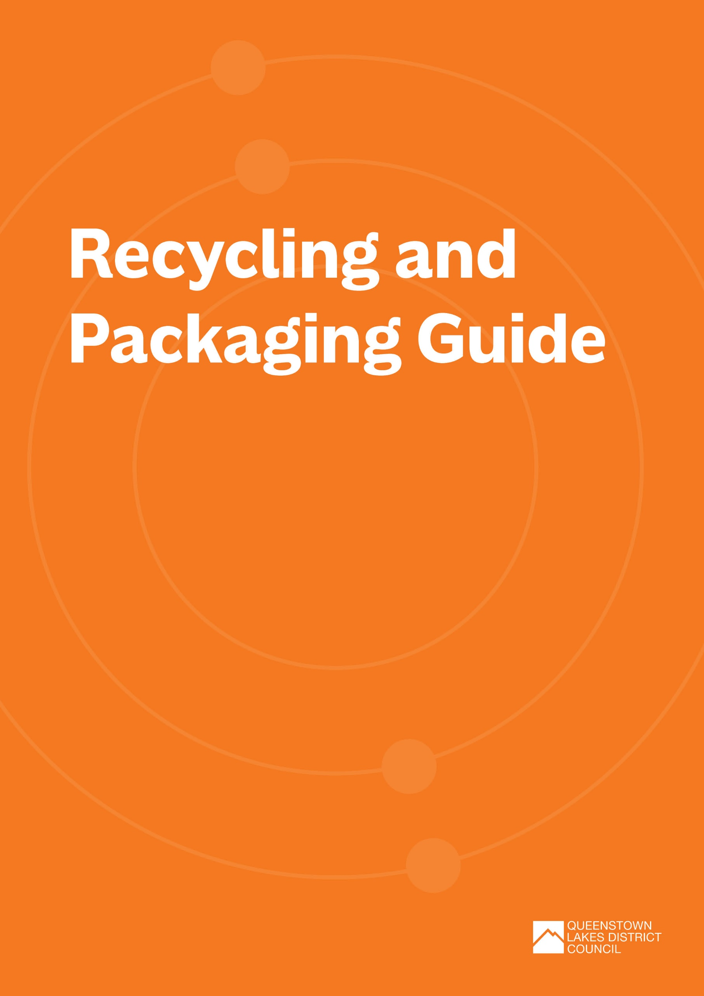
Recycling and Packaging Guide
In the Queenstown Lakes District, most recycling is sorted at the Materials Recovery Facility (MRF) in Frankton before being transported to various local and international markets for reprocessing.
This is an easy guide to what can and can't be recycled through our districts MRF.
Your waste contractor(s) may be able to provide additional specialist recycling options for materials that cannot be recycled through our MRF, or you can check out the comprehensive A-Z Rubbish and Recycling Directory to find out where other unwanted items can be dropped off for reuse, recycling, or safe disposal.
MIXED RECYCLING:
Materials need to be clean to be recycled. If recycling is very dirty, it is considered contaminated and must be landfilled.
Items | Requirements | Image
Paper | Clean and dry paper, including junk mail, newspapers, paper bags, and office paper can be recycled.  No shredded paper or paper contaminated with food or grease.  Single-use paper or coffee cups go in the rubbish. |   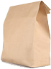
Cardboard (including pizza boxes free from grease and food) | Only recycle clean, dry and flattened cardboard.  Food contaminated cardboard or carboard that is lined with foil or plastic needs to go in the rubbish bin. This includes single-use coffee cups.  Cardboard cores, commonly found in printing or carpet roles, can't be recycled because they are contaminated by the high volume of glue used in their construction. Dispose of these as rubbish. |   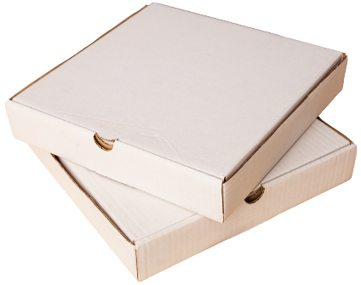
Aluminium cans | Must be empty and under 4 litres in size. | 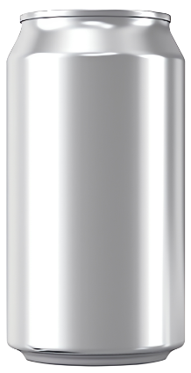
Steel cans | Must be empty, clean and under 4 litres in size. | 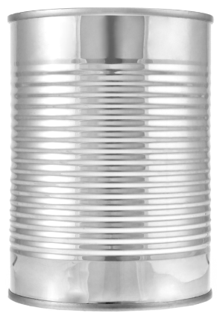
Plastic bottles, trays, and containers marked with recycling symbols ♳, ♴ and ♷ | Free of food and drink.  No items smaller than the palm of your hand or larger than 4 litres.  No lids. | 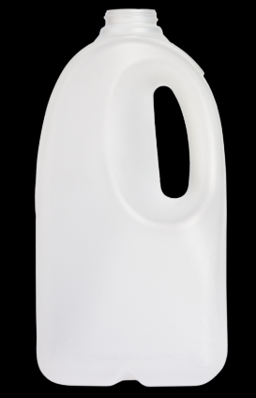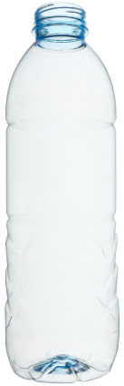
Common contaminants in mixed recycling include:
Items | Requirements | Image
Single-use coffee cups and lids | These can’t be recycled due to mixed materials. If you cannot avoid the use of these by implementing reusables, they must go in the rubbish bin. | 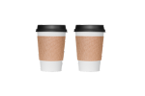
Soft plastics | Soft plastics, like plastic bags, can cause big problems at the MRF when they get tangled in the machinery. | 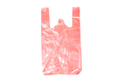
Cartons or tetrapaks | If you cannot avoid the use of these, contact Wastebusters who may be able to accept them as a specialised item. | 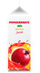
Food or drink contaminated recyclable materials | Although some materials are recyclable, in practice they are often contaminated with leftover food or drink, which makes recycling these items at events unviable.

GLASS RECYCLING:
Glass recycling is very sensitive to contamination so make sure you keep your glass bins free of mixed recycling or general rubbish.
Put other types of glass, like windows, drinking glasses, lightbulbs, perfume and moisturiser bottles, mirror, heatproof (e.g. Pyrex) in the rubbish bin.
Items | Requirements | Image
Glass bottles and jars. | Specific to products that once contained food or beverages  Must be empty and clean.  No lids.  All colours accepted. | 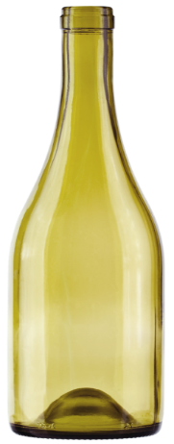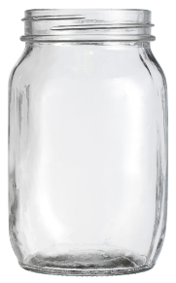
Common contaminants in glass recycling include the following:
Items | Requirements | Image
Drinking glasses | Drinking glasses, including wine glasses, contaminate our glass recycling. Broken items should be disposed of in the rubbish. | 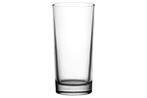
Ceramics | Ceramics including cups, plates and bowls, contaminate our glass recycling. Broken items should be disposed of in the rubbish. | 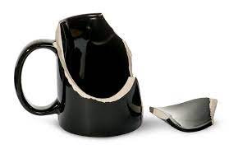
Top Tip: Lions Clubs throughout Aotearoa New Zealand regularly collect can tabs, as well as the screw tops off wine bottles, which contain aluminium and can be recycled in the same way. The tabs are sold to recyclers and the funds raised are passed on to the Kidney Kids Foundation. Contact the local Lions club for more information: https://e-clubhouse.org/sites/queenstown/

HARD-TO-RECYCLE AND SINGLE-USE PLASTICS
To support Aotearoa New Zealand’s move towards a low-waste, circular economy, the Ministry for the Environment have restricted or banned a range of hard-to-recycle plastics and single-use items including:
- Plastic tableware (plates, bowls, platters, trays and cutlery made primarily of any type of plastic (including recyclable, degradable and compostable plastics);
- Cutlery (all utensils used to eat food – spoons, forks, knives, sporks, splayds and chopsticks).
- Plastic drinking straws that contain any plastic (including recyclable, degradable, or compostable plastics).
- Plastic drink stirrers
- Plastics with pro-degradant additives
- Polystyrene and expanded polystyrene takeaway food and drink packaging.
For more information on these bans visit the Ministry for the Environments website: Phasing out hard-to-recycle and single-use plastics | Ministry for the Environment
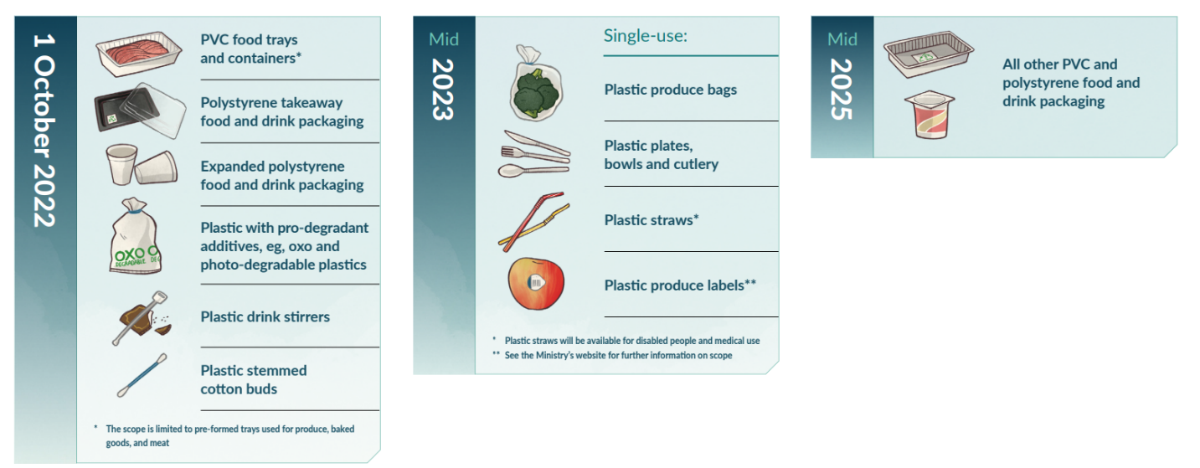
COMPOSTABLE SERVEWARE OR PACKAGING
There’s a perception that compostable serveware or packaging is lighter on the earth. The reality is these items are still single-use and come with many challenges. We recommend a cautious approach to using compostable products.
The Challenges
- Lack of certification and labelling requirements in Aotearoa New Zealand. Terms like ‘degradable’, ‘biodegradable’, ‘home compostable’, and ‘commercially compostable’ are often used interchangeably, with a limited understanding of the appropriate disposal pathways for these items.
- Compostable serveware is still single-use. The production and processing of compostable serveware and packaging still requires energy and natural resources; an environmental footprint that could be offset with reuse systems.
- Recycling contamination and methane production. If put in recycling bins, compostable products contaminate recycling streams. When thrown into a rubbish bin, compostable products go to landfill where they produce methane in the anaerobic conditions (a potent greenhouse gas contributing to climate change). When littered, compostable products do not degrade causing harm to wildlife.
- Harmful additives. The more research we do, the more we uncover that a lot of compostable packaging contains chemicals, additives, inks, and dyes, and even microplastics that contaminate the soil we then use to grow food and pose a risk to human health.
- Lack of infrastructure. We have limited sorting and processing infrastructure in Aotearoa New Zealand to effectively manage compostable packaging, for most compostable products that require high temperatures of ‘industrial’ composting systems to degrade. Because compostable packaging products pose a risk to the quality of the final compost product there are limited end markets for this type of compost in New Zealand. There is also currently no market demand driving composters to process compostable products, or to upscale existing infrastructure.
When should I use compostable serveware?
Given the challenges, compostable serveware or packaging should only be considered where elimination, reduction and reuse are not suitable alternatives.
When exploring the use of compostable products consider:
- Can you certify that the compostable product, in its final form, to a recognised overseas standard? The WasteMINZ It’s Complicated guide lays out how to check that any commercial or home composability claims are backed up with an appropriate certification standard.
- Can you ensure the product is free from intentionally added per – and poly-fluorinated alkyl substances?
- Check the availability and accessibility of composting facilities. For compostable products to be effective, there must be proper infrastructure in place to compost them. Whether its someone's home compost, a community garden, or an industrial facility, check that the composting facilities, can accept the specific type of compostable materials being used. For a list of commercial composting facilities that accept compostable serveware and packaging visit: NZ Facilities that Accept Compostable Packaging public | WasteMINZ
- Educate event attendees about the proper disposal of compostable items. Clearly communicate the difference between compostable and non-compostable materials and provide designated bins for compostable waste.
Home Composting Standards
Look for these logos when choosing home compostable serveware (only do this if you have access to a private or home-based composting facility, otherwise this type of serveware must go to landfill).
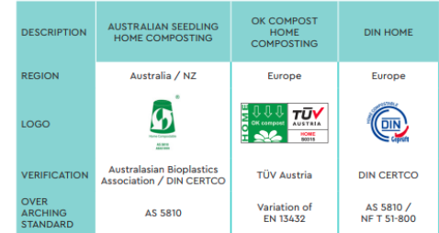
Industrial / Commercial Composting Standards
Look for these logos when choosing industrially compostable serveware (only do this if you have access to an industrial composting facility that is willing to accept this material, otherwise this type of serveware must go to landfill).
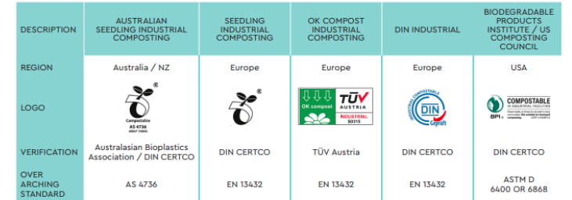
Source: WasteMINZ It’s Complicated packaging guide.
Commercial Composting Facilities
There is currently no commercial composting facility in Queenstown Lakes District, so most ‘commercially compostable serveware’ will go to landfill if it cannot be sent to an out of district industrial facility.
There are 10 industrial facilities in Aotearoa New Zealand and two community facilities that currently accept compostable packaging, the nearest being Timaru.
Transporting industrially compostable material out of district creates travel emissions and sending it to landfill creates methane emissions as the organic material breaks down. Prioritise reusable and home compostable recyclable packaging and choose industrially compostable serveware as the last option.
Additional Guidance
The WasteMINZ Organic Materials Sector Group have produced a series of guidelines for advertising compostable and biodegradable packaging. These can be found online here: Our guidelines (wasteminz.org.nz)
SURPLUS FOOD AND FOOD SCRAPS
Surplus edible food can fill hungry bellies instead of filling landfills. Check out the Supplier Directory to find a local food rescue organisation like KiwiHarvest. They may be able to collect and donate any surplus food from your event.
Diverting food scraps is important because it reduces the greenhouse gas emissions created when organic material (like banana peels) ends up in the landfill. Your event food scraps can be a valuable resource, by separating and composting these you can return nutrients back to the soil.
Food scraps from your event can be composted in private compost bins, community gardens, or through worm and pig farmers in the district. You will need to check with your compost service supplier whether they accept things like meat and citrus.
TOP TIP: If you are collecting only food scraps for composting, make sure you have good signage to make it clear that no compostable serveware or packaging can be accepted.

